Q1. Create a simple html using basic tags.

Code: <html>

<head><title>HTML</title></head>

<h1>Hola</h1><br><br>

<body><p>HTML</p></body>

</html>

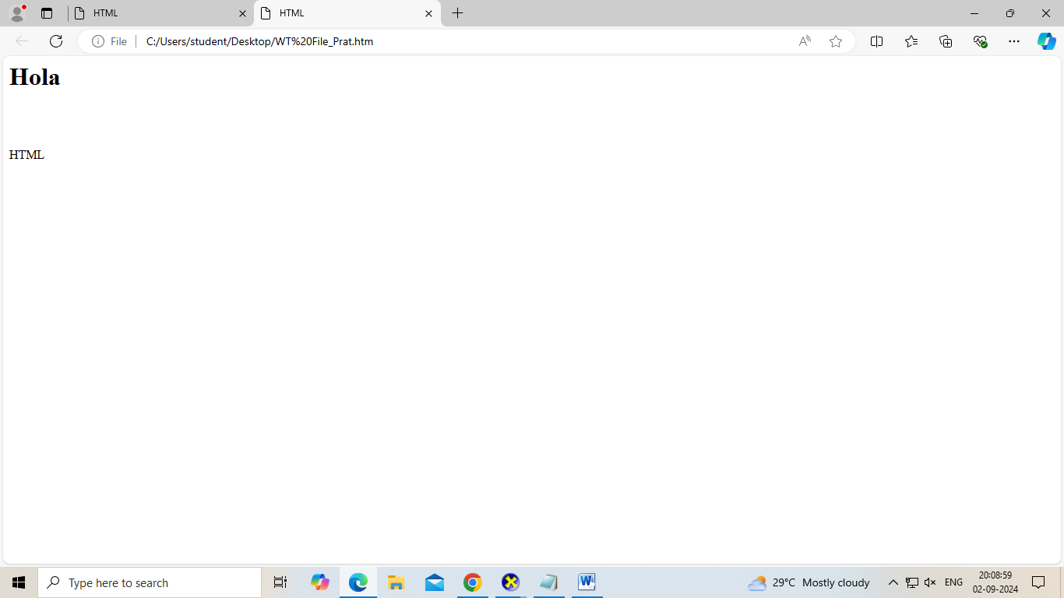

Q2. Create web page that displays your name to the screen.

Code: <html>

<head><title>Name</title></head>

<h1>Pratyansh Sharma</h1>

</html>

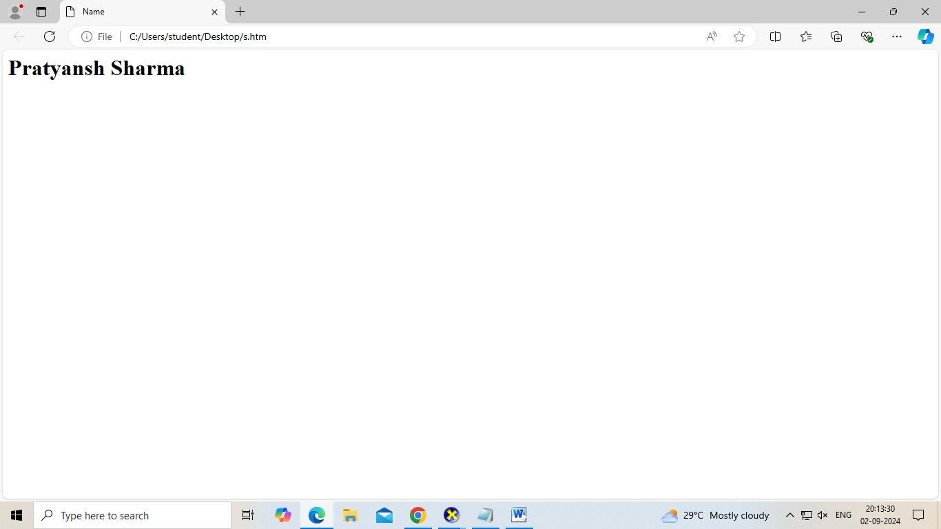

Q3. Create a web page and show the output from 1 to 10 in separate lines.

Code: <html>

<h1>Output</h1>

<body><p>1<br> 2<br> 3<br> 4<br> 5<br> 6<br> 7<br> 8<br> 9<br> 10</p></body>

</html>

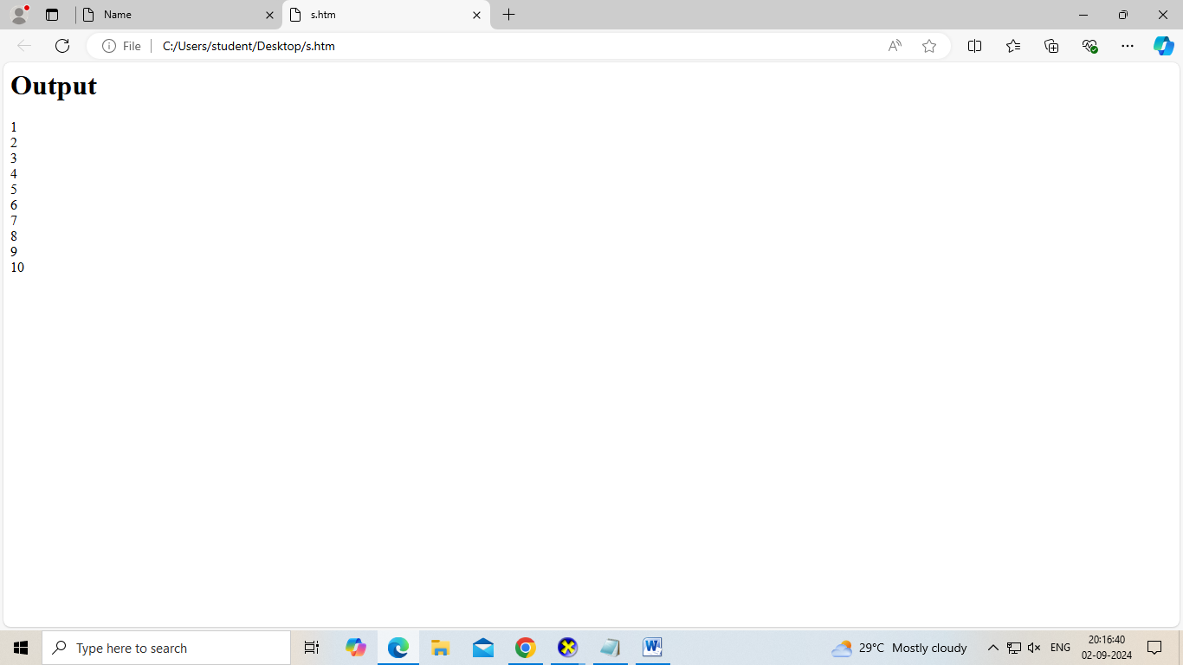

Q4. Create a web page and show the output from 1 to 10 in separate lines, each number being in different color.

Code: <html>

<h1>Output</h1>

<body><p>1<br> <font color='blue'> 2<br> <font color='green'> 3<br> <font color='purple'> 4<br> <font color='yellow'> 5<br> <font color='gray'> 6 <br> <font color='orange'> 7<br> <font color='pink'> 8<br> <font color='violet'> 9<br> <font color='cyan'> 10</p></body>

</html>

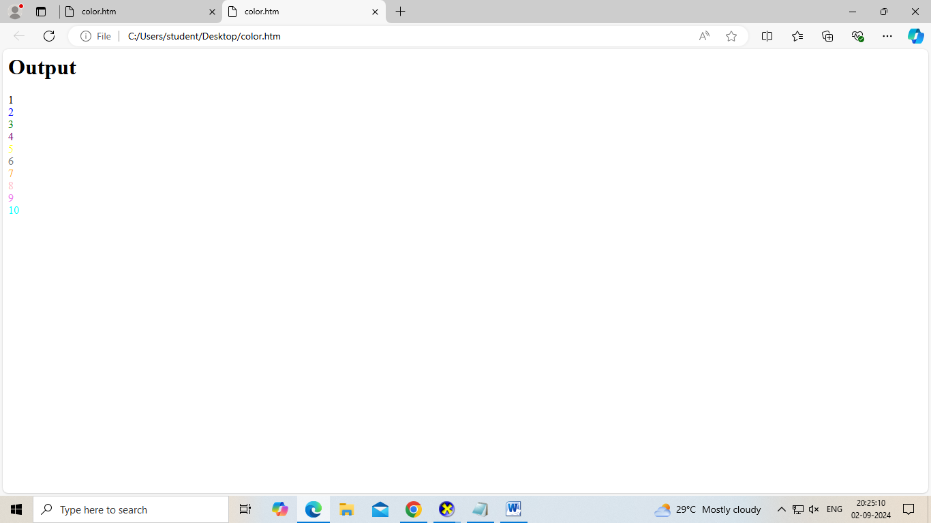

Q5. How do I make a picture as a background on my web pages?

Code: <html>

<h1>Image</h1>

<body background="C:\Users\student\Desktop\slave.png"> shadow </body>

</html>

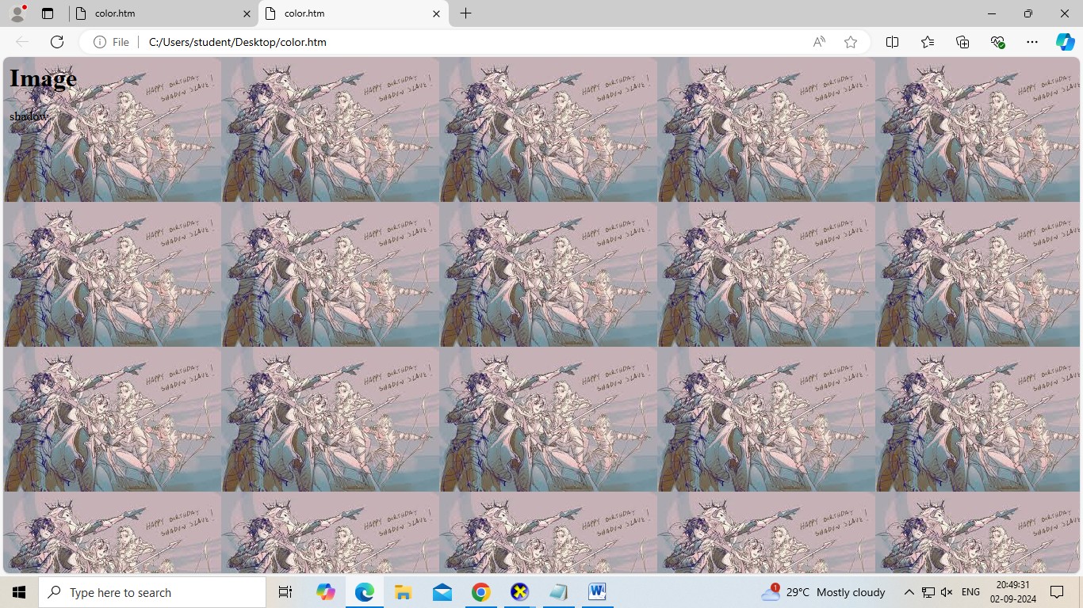

Q6. Create a web page to print a paragraph with 4-5 sentences, each sentence shall have a different font.

Code: <html>

<h1>Fonts</h1>

<body> <p> <font face="Arial">Life is good </font> <br>

<font face="Times New Roman">Life is great</font> <br>

<font face="Georgia">Life is awesome</font> <br>

<font face="Courier">Life is excellent</font> <br>

<font face="Comic Sans MS">Life is worth living</font> <br>

</body>

</html>

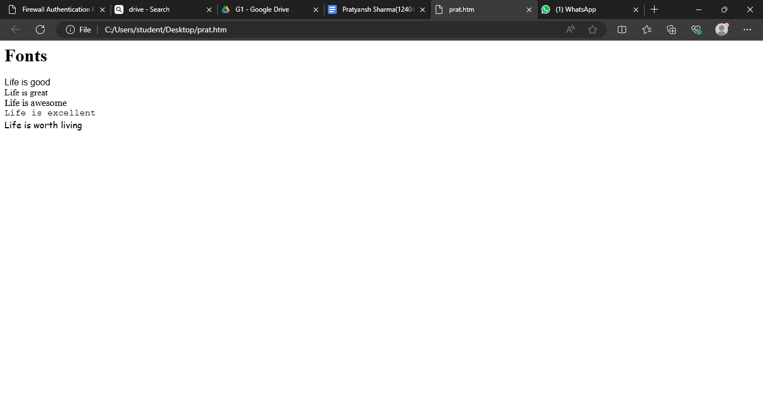

Q7. Write HTML code to print a paragraph that is description of a book. It shall include title of the book, author name, name and title should be underlined and all adjectives should be bold and italiics

Code-<html> <head> <title> <u>Shadow Slave</u> </title> </head>

<h1><u>Shadow Slave</u> <sub>-Guilty3</sub> </h1>

<body> <p>

"Shadow Slave" is a gripping web novel that delves into the life of a young man who finds himself bound to a mysterious shadowy entity after a near-fatal accident. As he navigates this newfound connection, he discovers hidden powers and uncovers dark secrets about the world around him. The story masterfully blends elements of fantasy, action, and psychological intrigue, drawing readers into a world where shadows hold both peril and promise. With its intricate plot and deep character development, "Shadow Slave" keeps readers on the edge of their seats, eager to unravel the next twist in the protagonist's journey. </p> </body>

</html>

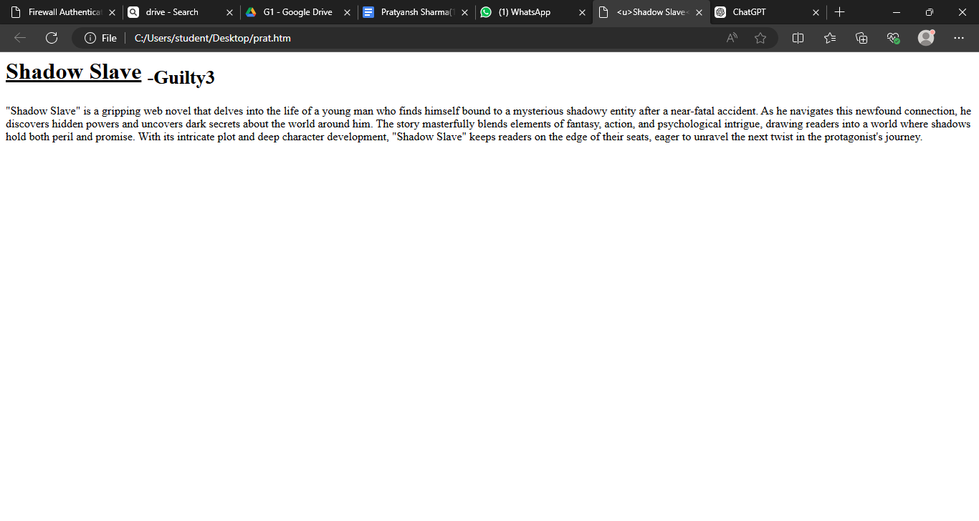

Q8. Write a code to print your name using heading tag, where every letter should be of different size

Code-<html>

<body>

<p> <h1>P</h1> <h2>R</h2> <h3>A</h3> <h4>T</h4> <h5>Y</h5> <h6>A</h6> <h1>N</h1> <h2>S</h2> <h3>H</h3> </p> </body>

</html>

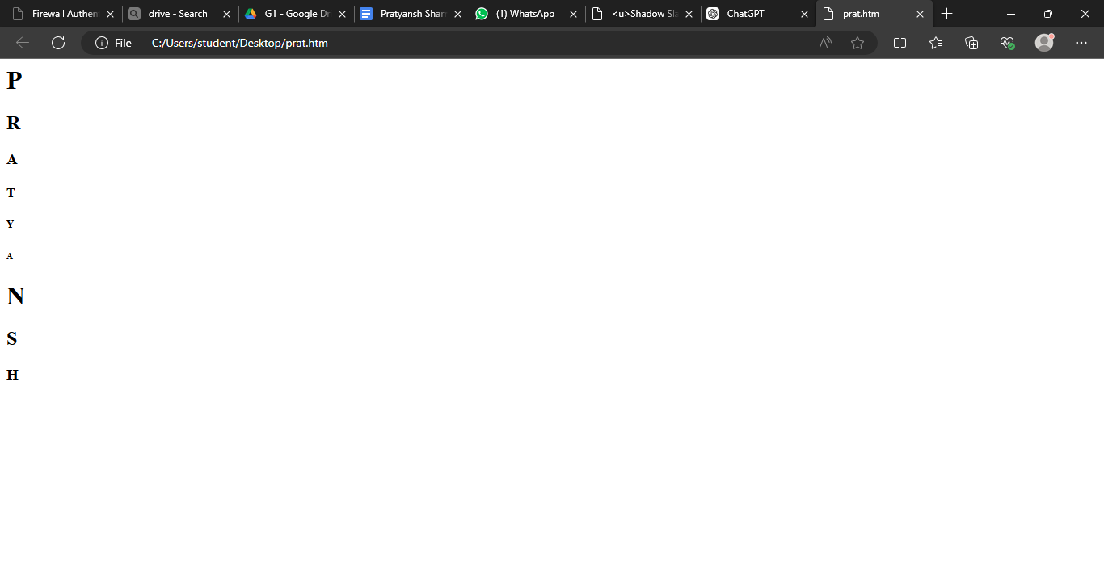

Q9. Write code to print sequence of numbers from 1-20

Code- <html>

<body>

<p> <ul><li>1</li>

<li>2</li>

<li>3</li>

<li>4</li>

<li>5</li>

<li>6</li>

<li>7</li>

<li>8</li>

<li>9</li>

<li>10</li>

<li>11</li>

<li>12</li>

<li>13</li>

<li>14</li>

<li>15</li>

<li>16</li>

<li>17</li>

<li>18</li>

<li>19</li>

<li>20</li>

</ul> </p>

</body>

</html>

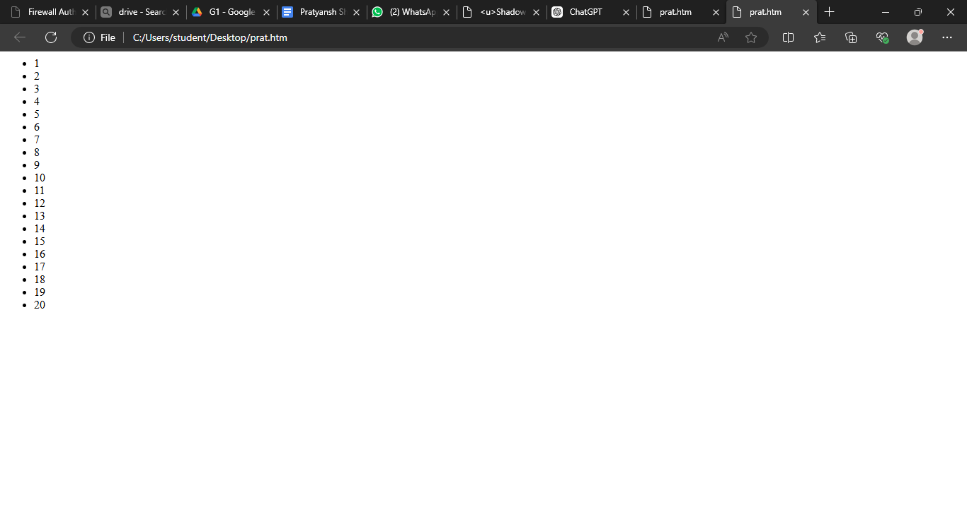

Q10. Write HTML code to display an image with border of size with width 200, height 200 pixels, leaving Hspace and Vspace of your choice with image hanging in the right side on the screen.

Code- <html>

<head>

<title>Image Example</title>

</head>

<body>

<img src="C:\Users\User\Desktop\shadow.jpg" width="500" height="500" align="right">

</body>

</html>

Q11. Write HTML code to create a web page with heading. The heading shall

be displayed at the top-center of the page and the image shall be at the center,

just below the heading.

Code- <html>

<head>

<title>Image Example</title>

</head>

<body>

<center><h2>Heading</h2></center>

<center><img src="C:\Users\User\Desktop\shadow.jpg" width="500" height="500"></center>

</body>

</html>

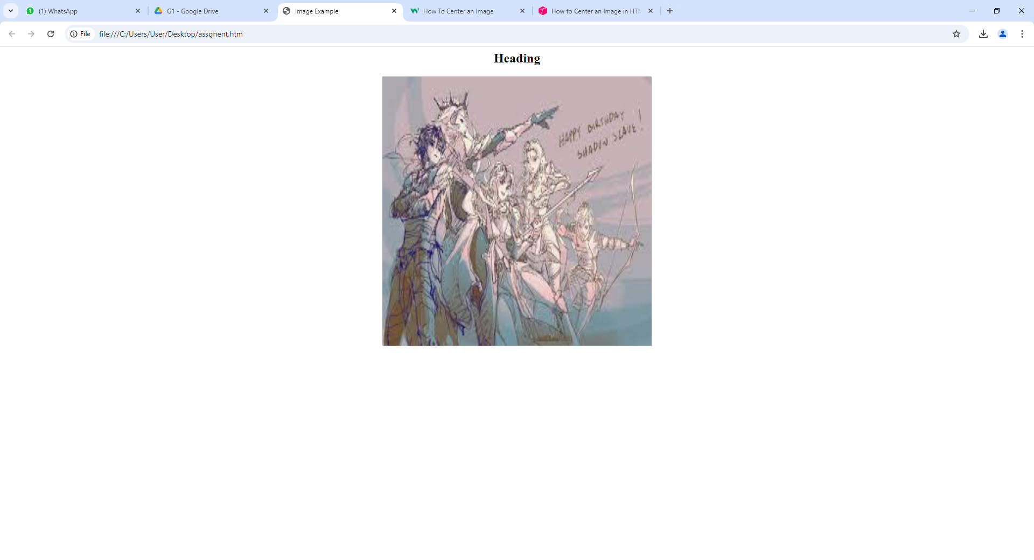

**Question 12) Write HTML code using Multimedia tags.**

**INPUT-**

<html>

<head>

<title> multimedia tags</title>

</head>

<body>

<h1> multimedia tags: </h1>

<h1>img</h1>

<center>

<img src="C:\Users\User\Desktop\shadow.jpg" alt="mask" height="450" , width="450"/>

<h1> audio </h1>

<audio src="C:\Users\User\Downloads\mixkit-arcade-retro-game-over-213.wav" controls/>

</body>

</html>

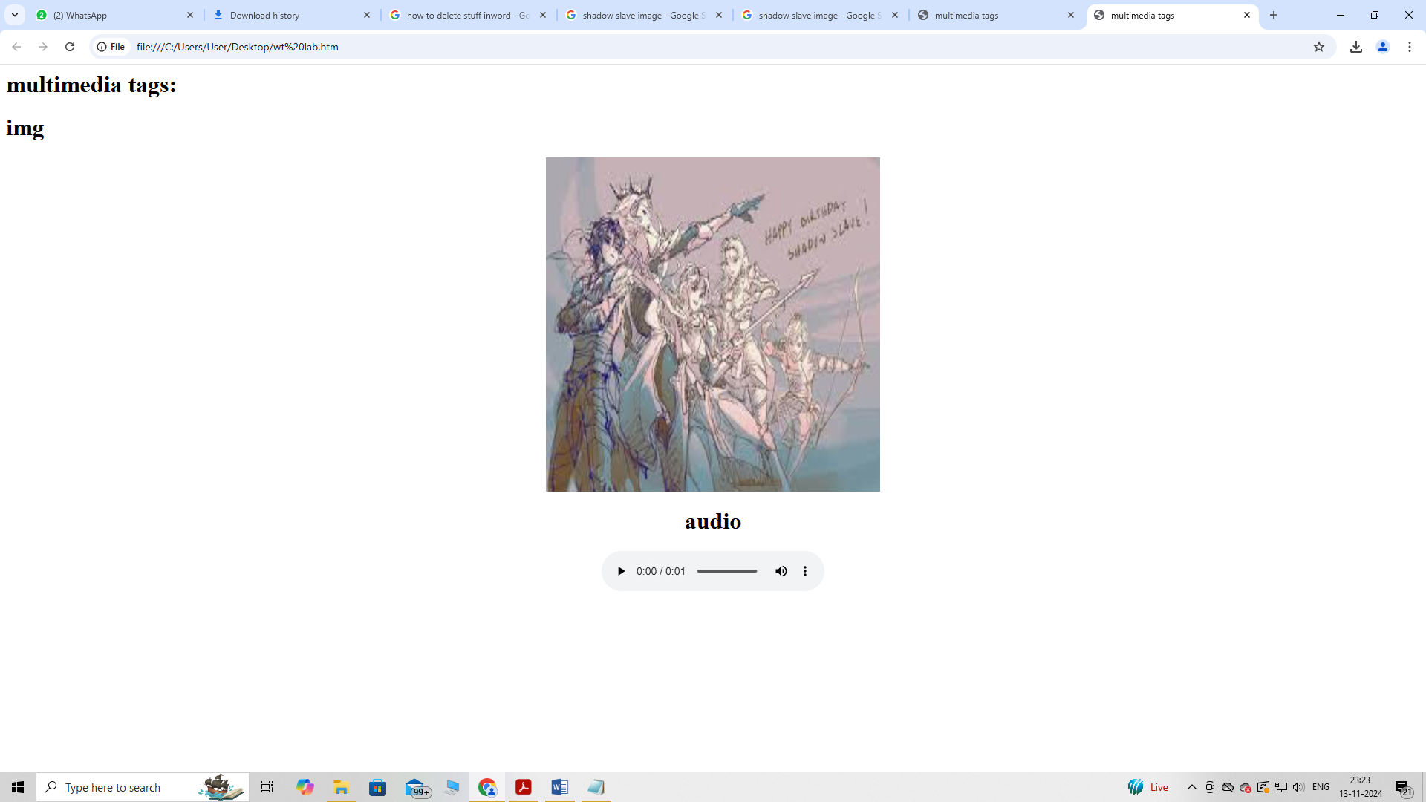

**Question 13) Create a Table using Rowspan and Colspan taking example of student**

**Record .**

**INPUT-**

<html>

<head></head>

<body>

<table border='4pt'>

<tr>

<th colspan='2'>Name</th>

<th>class</th>

<th>school</th></tr>

<tr>

<td rowspan='2'>ARJUN</td>

<td rowspan='2'>KUMAR</td>

<td> 11</td>

<td>mvps</td></tr>

<tr>

<td>A</td></tr>

<tr>

<td rowspan='2'>ARUN</td>

<td rowspan='2'>SINGH</td>

<td> 3</td>

<td>nvps</td></tr>

<tr>

<td>B</td></tr>

</body>

</html>

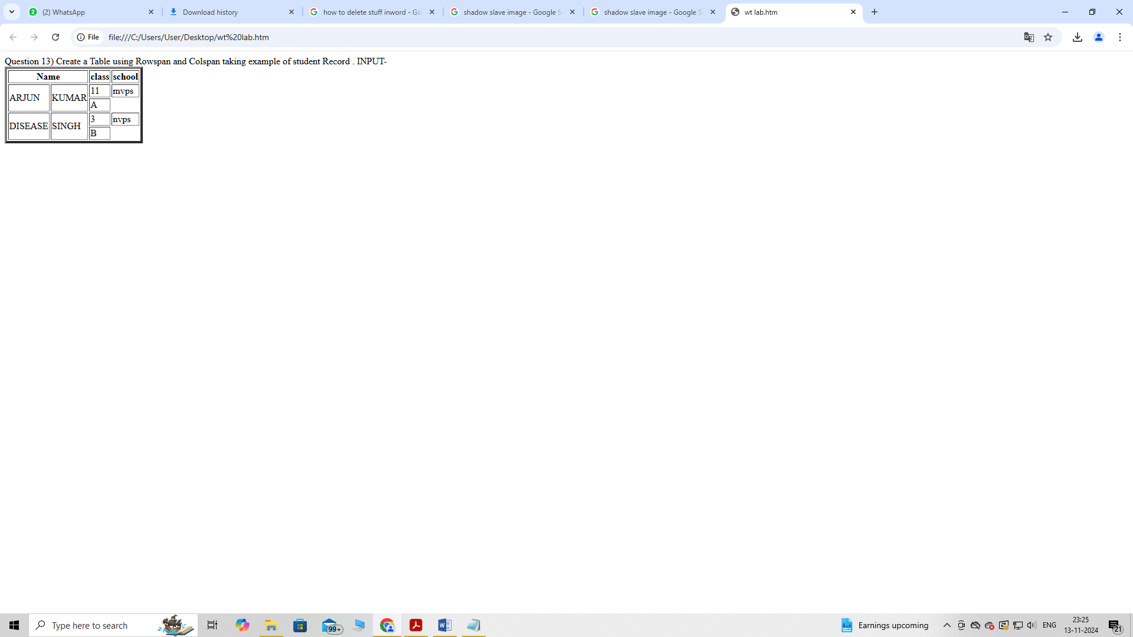

**Question 14) Write HTML code using table tag <table> and cellpadding and cell spacing**

**as its attributes.**

**INPUT-**

<html>

<head></head>

<body>

<table border="2pt" cellspacing="5pt" cellpadding="5pt">

<tr>

<th>S.no</th>

<th>Roll no.</th>

<th>Name</th>

<th>Address</th></tr>

<tr>

<td>1</td>

<td>123</td>

<td>ABC</td>

<td>FBD</td></tr>

<tr>

<td>2</td>

<td>456</td>

<td>XYZ</td>

<td>delhi</td></tr>

<tr>

<td>3</td>

<td>789</td>

<td>PQR</td>

<td>gurgaon</td></tr>

</table></body>

</html>

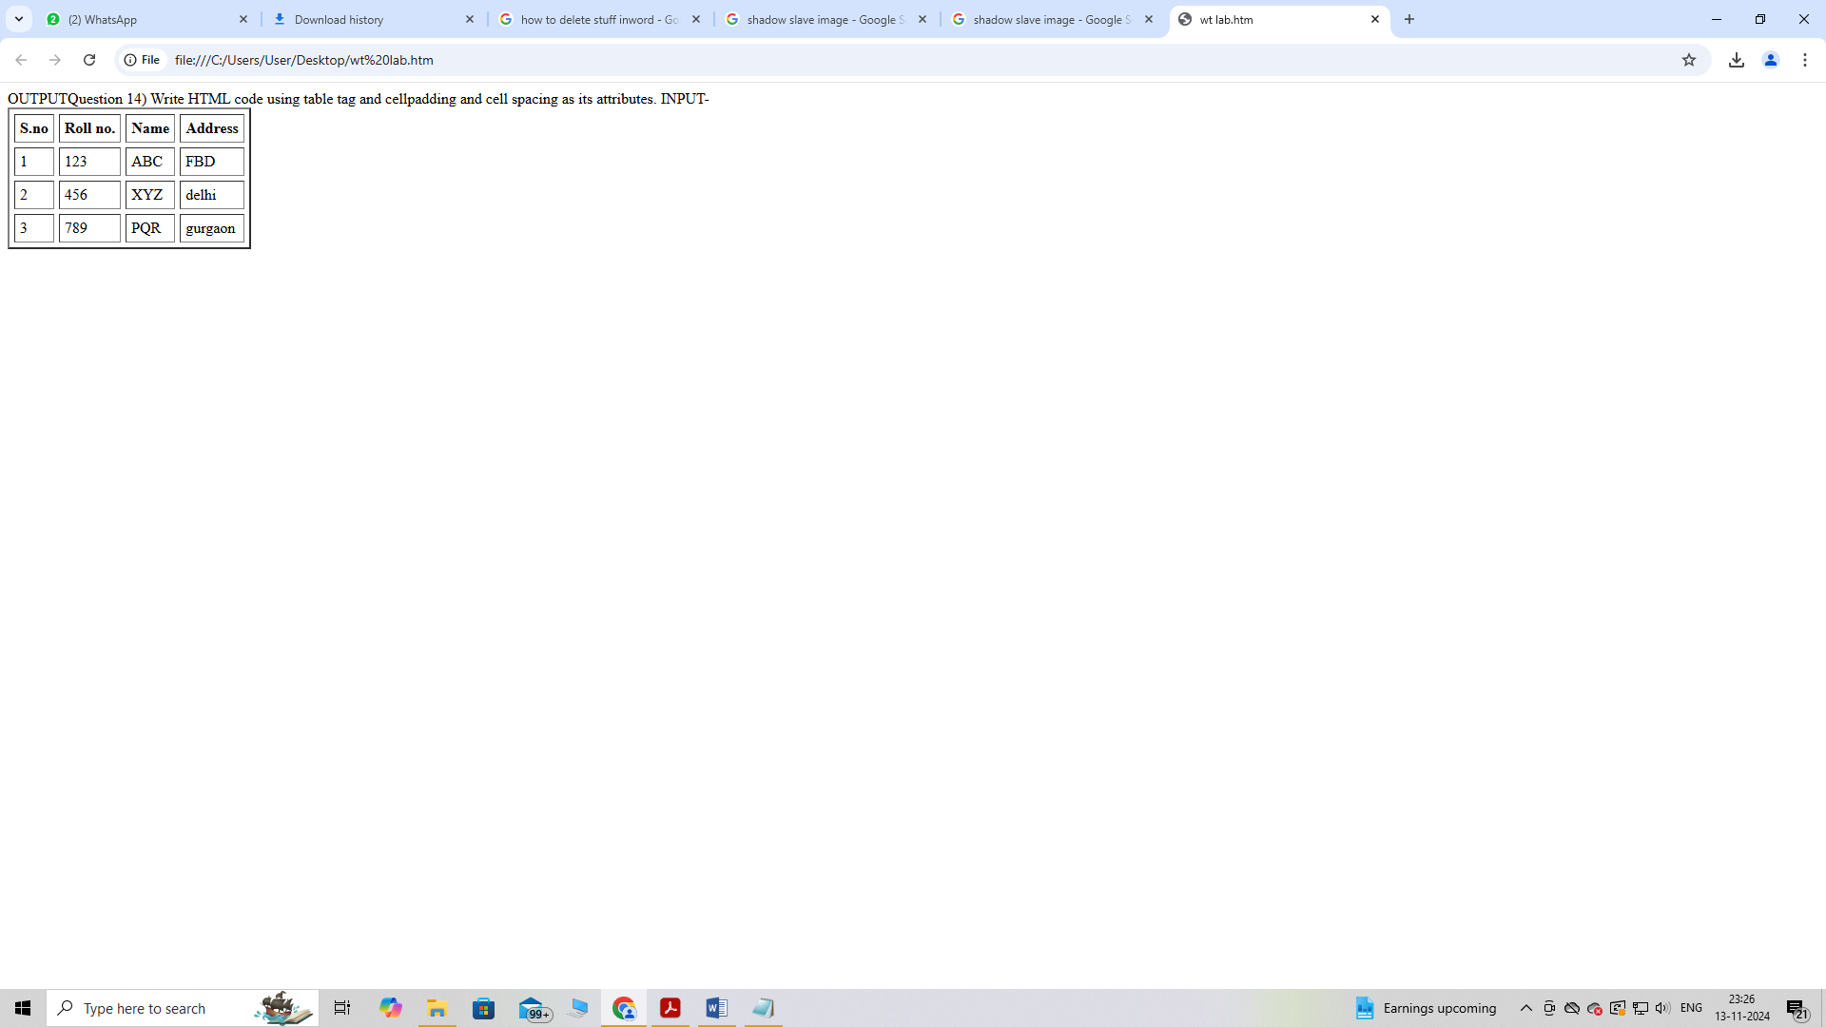

**Question 15) Create unordered, ordered and definition Lists taking example of your**

**subjects in MCA IST, IInd and IIIrd Semester.**

**INPUT-**

<html>

<head></head>

<body>

<h3> Subjects in BCA sem 1</h3>

<ol>

<li>Web technologies</li>

<ul>

<li>introduction to Networks</li>

<li>introduction to e-mail</li>

<li>introduction to html</li>

</ul>

<li>Introduction to IT & programming in C</li>

<ul>

<li>Input output devices</li>

<li>compilers,Interpreters,assemblers</li>

<li>various programs in C</li>

</ul>

<li>Mathematics</li>

<ul>

<li>matrices</li>

<li>surds and insurdes</li>

<li>trigonometry</li><ul><ol>

</body>

</html>

**OUTPUT -**

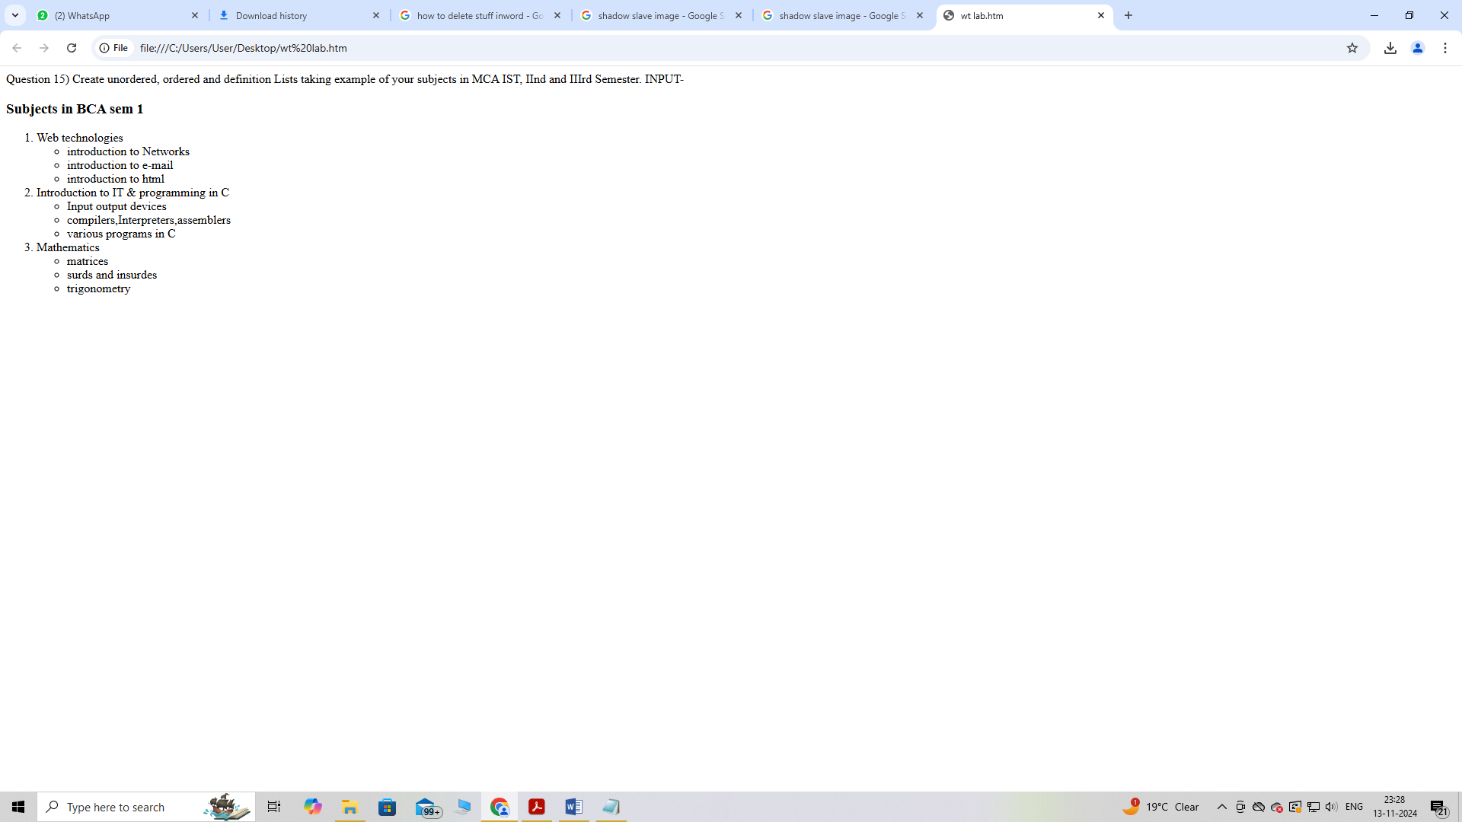

**Question 16) Write HTML code using <frameset> and <frame> tag with all its attributes .**

**INPUT-**

<html>

<head>

<title>Frameset Example</title>

</head>

<frameset rows="50%,50%" frameborder="1" bordercolor="black" framespacing="5">

<frame src="https://www.example.com" name="topFrame" scrolling="yes"

noresize="noresize" target="_self" />

<frame src="https://www.example.org" name="bottomFrame" scrolling="auto"

noresize="noresize" target="_self" />

</frameset>

<noframes>

<body>

<p>Your browser does not support frames. Please update your browser.</p>

</body>

</noframes>

</html>

**OUTPUT –**

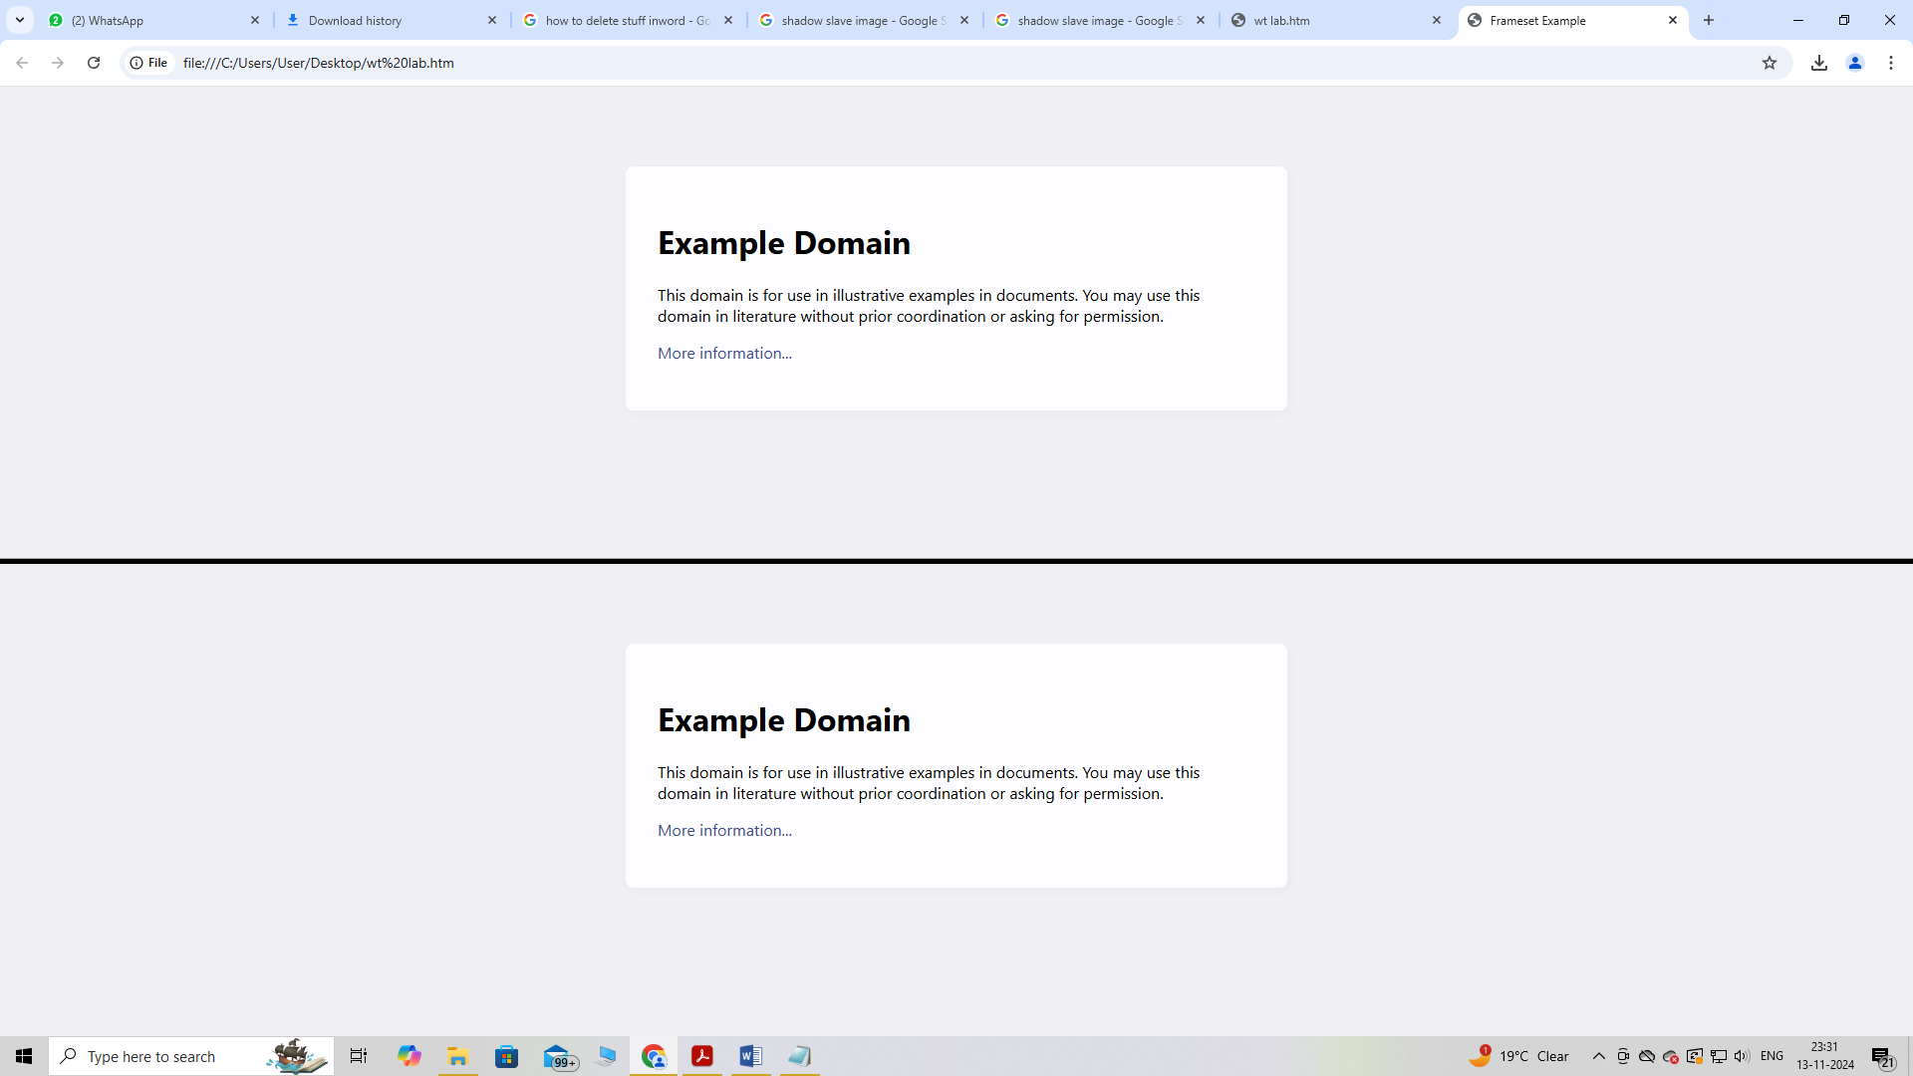

**Question 17 Write HTML code to design a form in HTML using controls and buttons such**

**as Teaxtbox, Textarea, password, submit button, browse button, drop-down menu**

**INPUT-**

<html>

<head>

<title>Form with Various Controls</title>

</head>

<body>

<h1>Registration Form</h1>

<form action="submit.php" method="post" enctype="multipart/form-data">

<label for="name">Name:</label>

<input type="text" id="name" name="name" required><br><br>

<label for="email">Email:</label>

<input type="email" id="email" name="email" required><br><br>

<label for="password">Password:</label>

<input type="password" id="password" name="password" required><br><br>

<label for="profile_pic">Profile Picture:</label>

<input type="file" id="profile_pic" name="profile_pic"><br><br>

<label for="country">Country:</label>

<select id="country" name="country">

<option value="india">India</option>

<option value="usa">USA</option>

<option

value="uk">UK</option>

</select><br><br>

<label for="message">Message:</label>

<textarea id="message" name="message" rows="5" cols="30"></textarea><br><br>

<input type="submit" value="Submit">

<input type="reset" value="Reset">

</form>

</body>

</html>

**OUTPUT –**

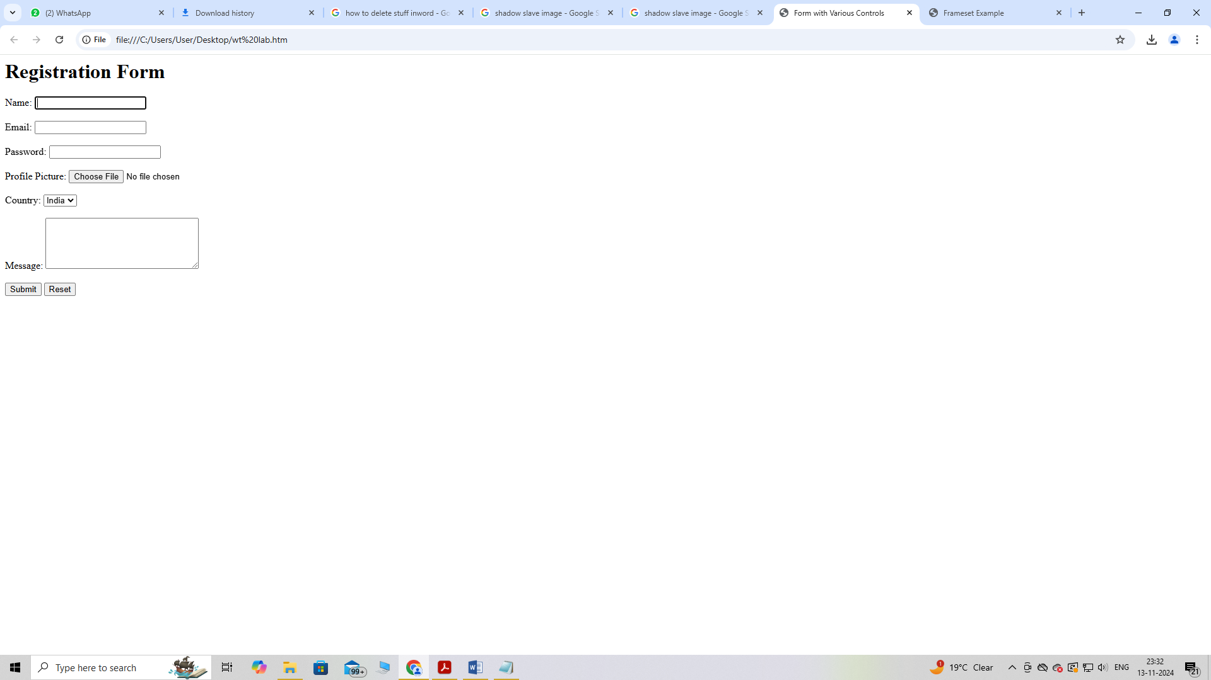

**Question 18. Write HTML code to design a Registration Form in HTML.**

**INPUT-**

<html>

<head>

<title>Grade Volleyball Registration Form</title>

</head>

<body>

<h1>Grade Volleyball Registration Form</h1>

<form action="submit.php" method="post">

<label for="first_name">Participant Name</label><br>

<input type="text" id="first_name" name="first_name" placeholder="First"><br>

<input type="text" name="last_name" placeholder="Last"><br><br>

<label for="age">Age</label><br>

<input type="number" id="age" name="age"><br><br>

<label for="grade">Grade</label><br>

<select id="grade" name="grade">

<option value="">Please select</option>

<option value="1">1</option>

<option value="2">2</option>

</select><br><br>

<label for="school_district">School District</label><br>

<input type="text" id="school_district" name="school_district"><br><br>

<label for="shirt_size">Shirt Size</label><br>

<select id="shirt_size" name="shirt_size">

<option value="">Please select</option>

<option value="s">Small</option>

<option value="m">Medium</option>

<option value="l">Large</option>

<option value="xl">Extra Large</option>

</select><br><br>

<label for="parent_first_name">Parent Name</label><br>

<input type="text" id="parent_first_name" name="parent_first_name"

placeholder="First"><br>

<input type="text" name="parent_last_name" placeholder="Last"><br><br>

<label for="emergency_contact">Emergency Contact</label><br>

<input type="text" id="emergency_contact" name="emergency_contact"><br><br>

<input type="submit" value="Submit">

</form>

</body>

</html>

**OUTPUT –**

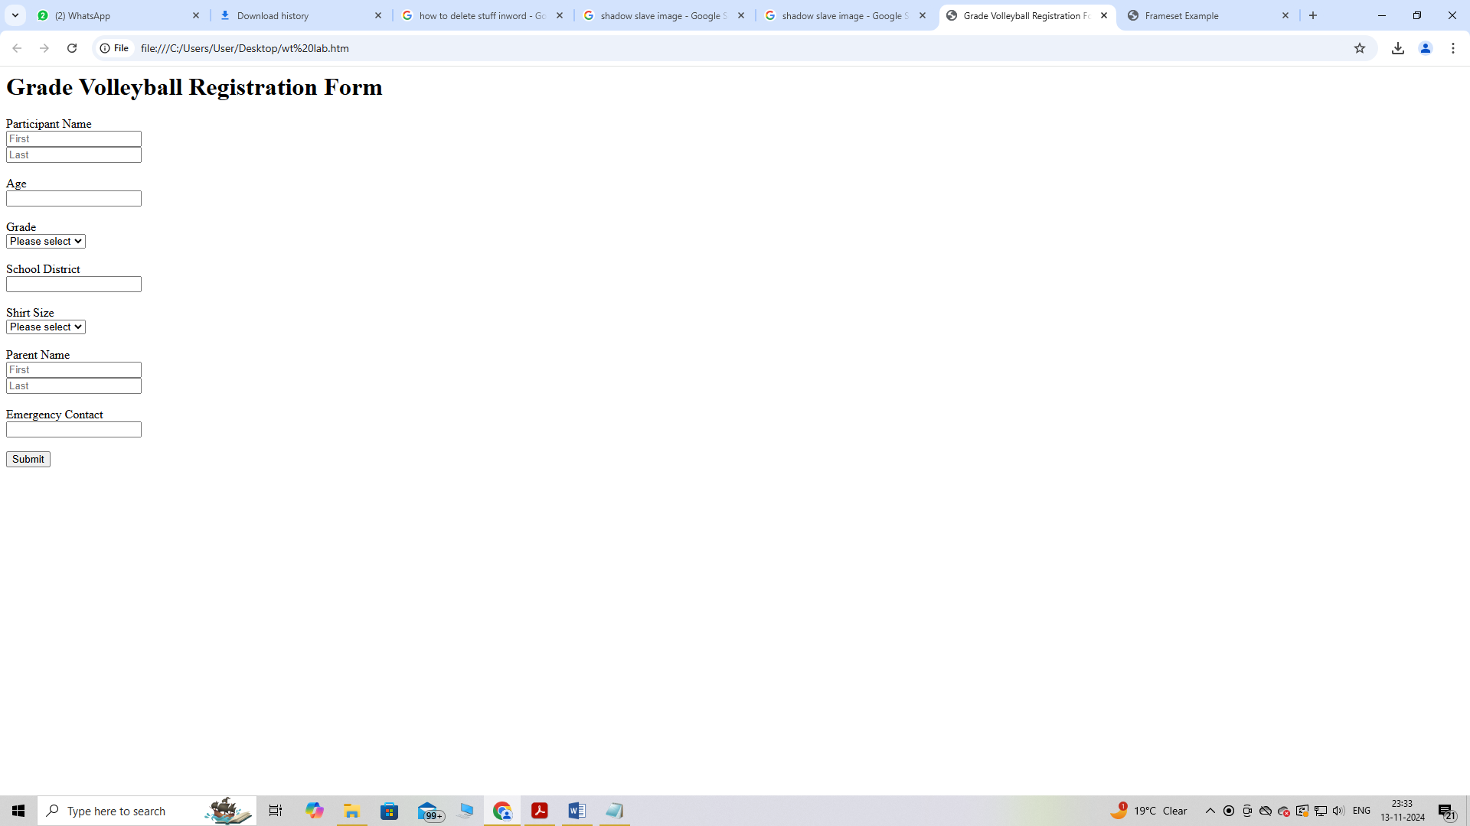

**Question 19) Write HTML code to design a student admission Form in HTML.**

**INPUT-**

<html>

<head>

<title>Student Admission Form</title>

</head>

<body>

<h1>Student Admission Form</h1>

<form action="submit.php" method="post">

<label for="student_name">Student Name</label><br>

<input type="text" id="student_name" name="student_name" required><br><br>

<label for="date_of_birth">Date of Birth</label><br>

<input type="date" id="date_of_birth" name="date_of_birth" required><br><br>

<label

for="gender">Gender</label><br>

<input type="radio" id="male" name="gender" value="male">

<label for="male">Male</label>

<input type="radio" id="female"

name="gender" value="female">

<label for="female">Female</label><br><br>

<label for="address">Address</label><br>

<textarea id="address" name="address"

rows="5" cols="30" required></textarea><br><br>

<label for="phone_number">Phone Number</label><br>

<input type="tel" id="phone_number" name="phone_number" required><br><br>

<label for="email">Email</label><br>

<input type="email" id="email" name="email" required><br><br>

<label for="class">Class</label><br>

<select id="class" name="class" required>

<option value="">Please select</option>

<option value="1">1</option>

<option value="2">2</option>

</select><br><br>

<label for="guardian_name">Guardian Name</label><br>

<input type="text" id="guardian_name" name="guardian_name" required><br><br>

<label for="guardian_contact">Guardian Contact</label><br>

<input type="tel" id="guardian_contact" name="guardian_contact" required><br><br>

<input type="submit" value="Submit">

</form>

</body>

</html>

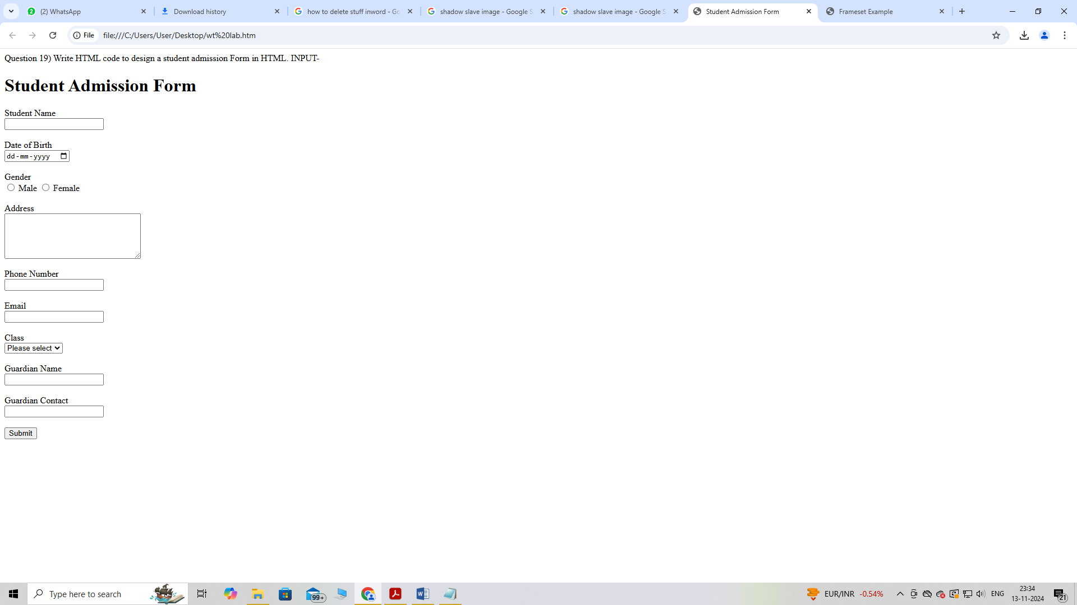

**Question 20) Create a proper home page of your own using any components and styles.**

**INPUT-**

<html>

<head>

<title>My Personal Website</title>

<link rel="stylesheet" href="styles.css">

</head>

<body>

<header>

<h1>My Name</h1>

<nav>

<ul>

<li><a href="index.html">Home</a></li>

<li><a href="about.html">About</a></li>

<li><a href="projects.html">Projects</a></li>

<li><a href="contact.html">Contact</a></li>

</ul>

</nav>

</header>

<main>

<section>

<h2>Welcome to My

Website!</h2>

<p>This is a brief introduction about myself. Feel free to explore my projects and contact

me.</p>

<img src="C:\Users\User\Desktop\shadow.jpg" alt="Profile Picture">

</section>

</main>

<footer>

<p>&copy; 2023 My Name</p>

</footer>

</body>

</html>

